Knight

Contents

1. Assets 2

a. Adding new enemy 2

b. Adding new vfx 3

c. Adding new item 4

d. Sway Grass 5

e. Adding new scene 7

2. Naming conventions: 9

3. Build 10

# Assets

## Adding new enemy

Step 1: Duplicating all the animation clips from the sprite (aesprite file)

Step 2: Add all the animation clips to the new animators.

Attention: to naming conventions

Step 3: Adding and creating behavior tree (enemy components)

Step 4: Creating a prefab from that.

Note: Finishing 1 enemy behavior before creating new one, because that will affect other behavior

## Adding new vfx

Step 1: Duplicating all the animation clips from the sprite (asesprite file) (if the vfx has animator)

Step 2: Add all the animation clips to the new animators.

Step 3: Adding and creating animator, etc, …

Step 4: Set and adjust VFX Scriptable Object (position, rotation, sprite and animator created)

Step 5: Drag the new SO to any player or enemy data.

Step 6: Drag to the object pooling object (if it is diff from the normal vfx)

## Adding new item

Step 1: Updating in ItemDatabase **CSV**

Step 2: Click the **Generate Item Database**

Step 3: The new item will be in this path

## Sway Grass

Step 1: Adding all grass on the ground in the Instance game object.

Step 2: Adding Grass Velocity Controller script for parent game object (Instance, Ground).

Step 3: Adding these components for Game Object you want to sway.

## Adding new scene

Step 1: Adding **exit id** in **clockwise** direction.

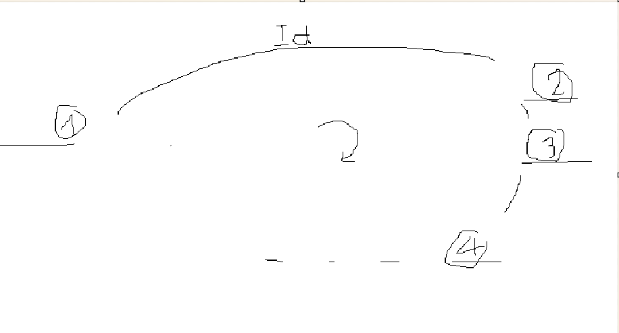

Step 2: Generating Load Code for the new name of the scene (Create fast menu for scene)

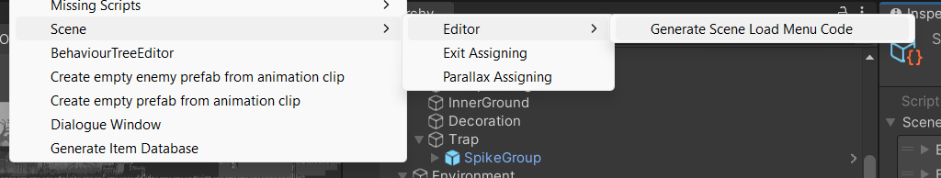

Step 3: Updating scene data (parallax, exit, …)

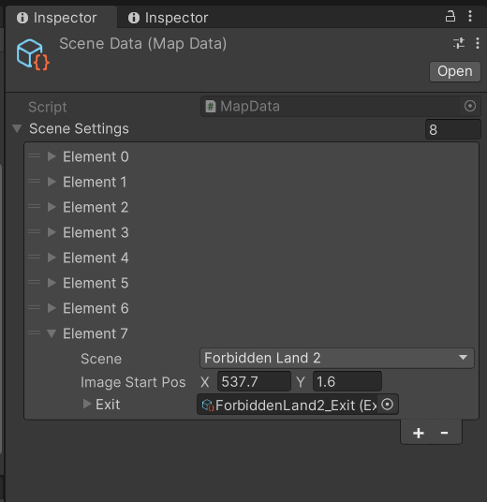

# Naming conventions:

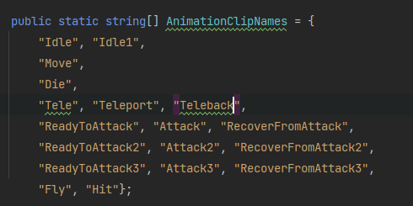

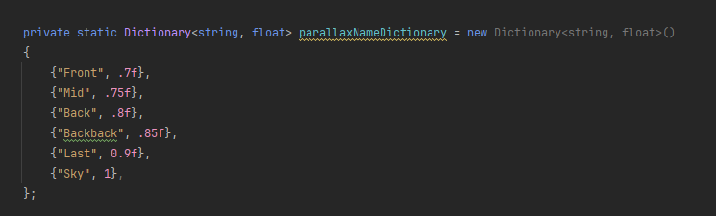

\\

# Build

Step 1: Select ----TEST--- prefab and turn it off.

Step 2: Then override ---TEST--- prefab (to apply to all scene).

Step 3: BUILD